***ASSIGNMENT 3:***

***TURTLE GAMES PROJECT***

***SEPTEMBER 2022***



**Javier Conde Pascual**

**LSE Data Analytics Career Accelerator**

**London School of Economics and Political Science**

*I, Javier Conde Pascual, certify that this is an original piece of work. I have acknowledged all sources and citations. No section of this assignment has been plagiarized.*



**TABLE OF CONTENTS**

Chapter 1. Scenario and system set up 1

Chapter 2. Analysis approach2

* 1. **Customer data analysis**
     1. First approach and insights to provided data4
     2. Customer Clustering5
     3. NLP using Python on customer reviews8
  2. **Sales data analysis**
     1. Exploratory Data Analysis (EDA) on sales with R11
     2. Data set normality and advanced plotting14
     3. MLR model and value prediction18

Chapter 3. Insights and recommendations24

List of figures28

Word count: 937

Own words: 937

Chapter 1

**Scenario and system set up**

The background, scenario, and context provided beforehand for this report are available [here](https://fourthrev.instructure.com/courses/438/assignments/1711). The business problem and key questions for the analysts’ team and the data are also provided, Figure 1.1. below.

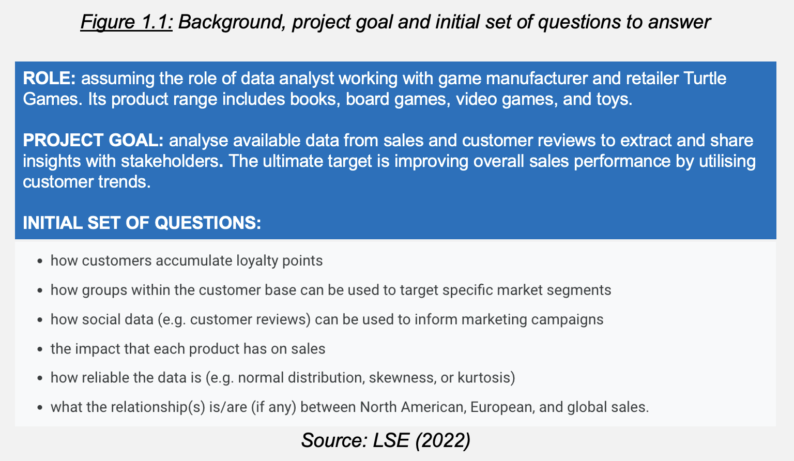

All project files are stored in [GitHub](https://github.com/JavierConde1976/LSE_DA301_assignment_Javier_Conde)to control overall project progression, different steps completed along the way and any changes made to the Python and R (using Jupyter/RStudio) code blocks.

Now the central Python/R repository in Github where the project files are stored is prepared, let’s study the analytical approach used.

Chapter 2

**Analytical approach**

This project approach has four key points:

1. Bringing stakeholders (marketing and sales departments) and data analysis team together through understanding the importance and risk-reducing advantages of methodical and thorough data analysis and data quality processes
2. Provide stakeholders with rigorous, accurate and realistic analysis on the data files provided through Python and R:
   * turtle_sales.csv (details of video games sold globally)
   * turtle_reviews.csv (details on customer reviews across products)

The aim is providing actionable insights and recommendations from them to bring measurable value to the business to reach the project goal.

1. Assessing the quality of the data and results obtained. To achieve best results this project will be divided in two parts: customer data analysis and financial analysis on company sales.
2. Reports/presentations material to be created as accessible as possible through very legible fonts (Arial), big font sizes (10-12 onwards when possible), clear head titles and colors that are color-blind and color-contrast friendly among other features.

With file preparation for Github, Phyton (Anaconda/Jupyter) and R (RStudio) completed (Figures 1.2 and 1.3 below), let’s now analyze and visualize the data provided.

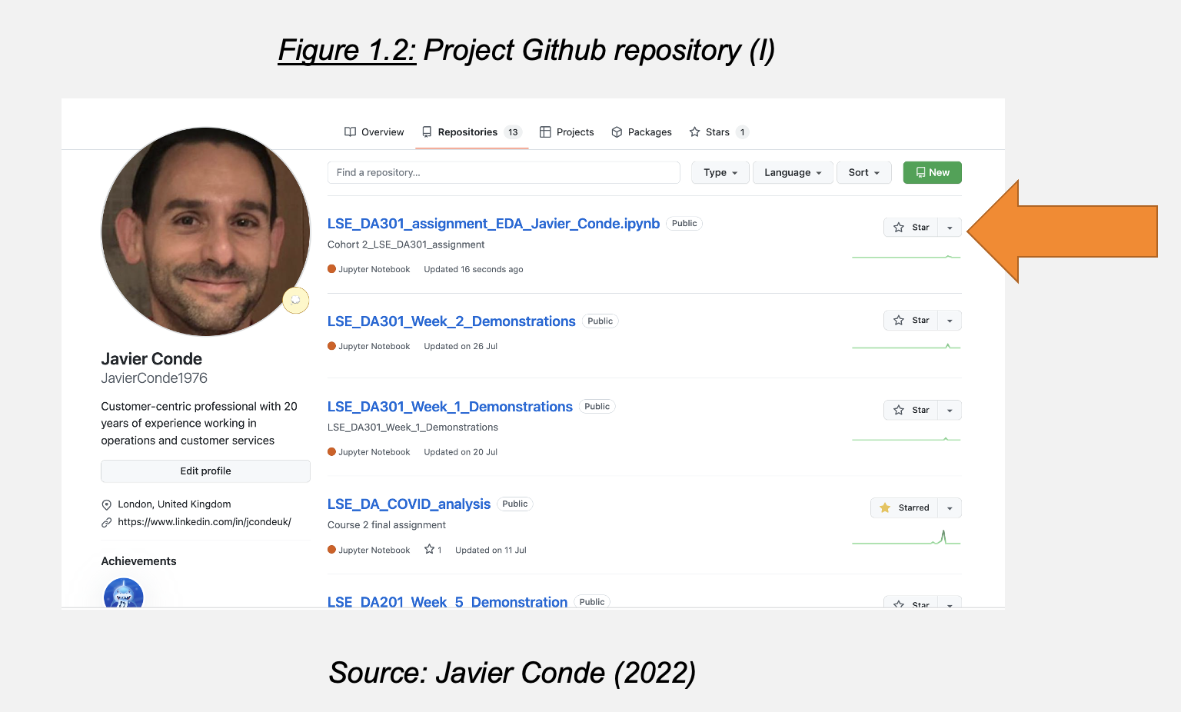

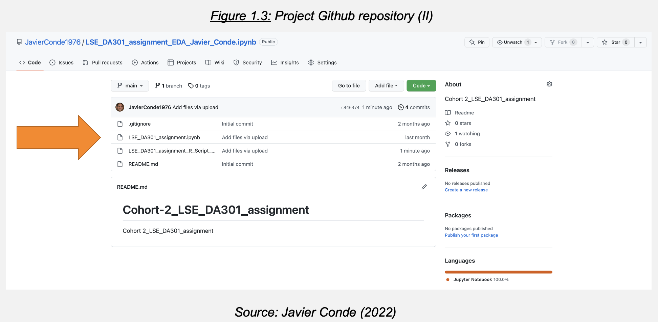

**2.1 Customer data analysis**

**2.1.1. First approach and insights to provided data**

The file turtle_reviews is cleaned, re-imported, and visualized (Figures 2.1, 2.2, 2.3).

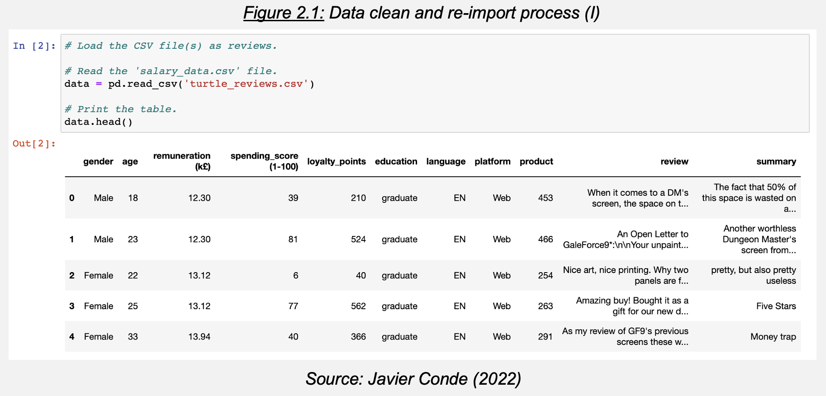

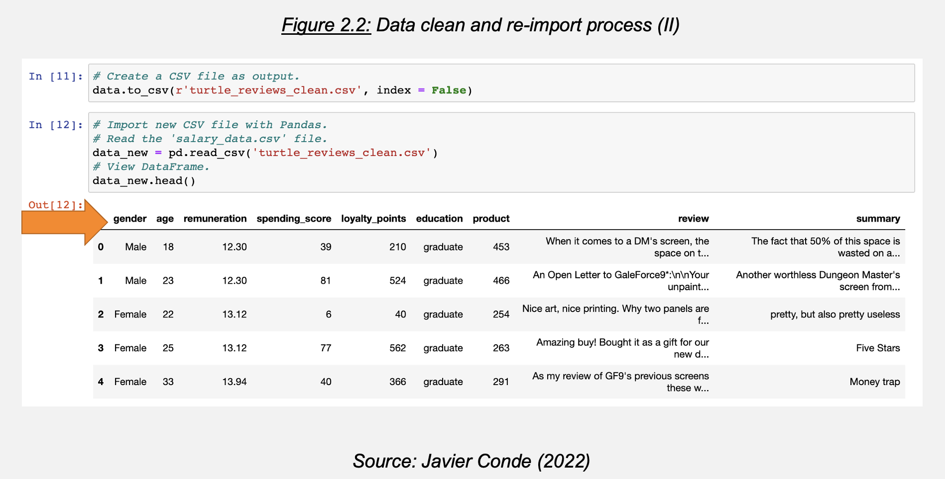

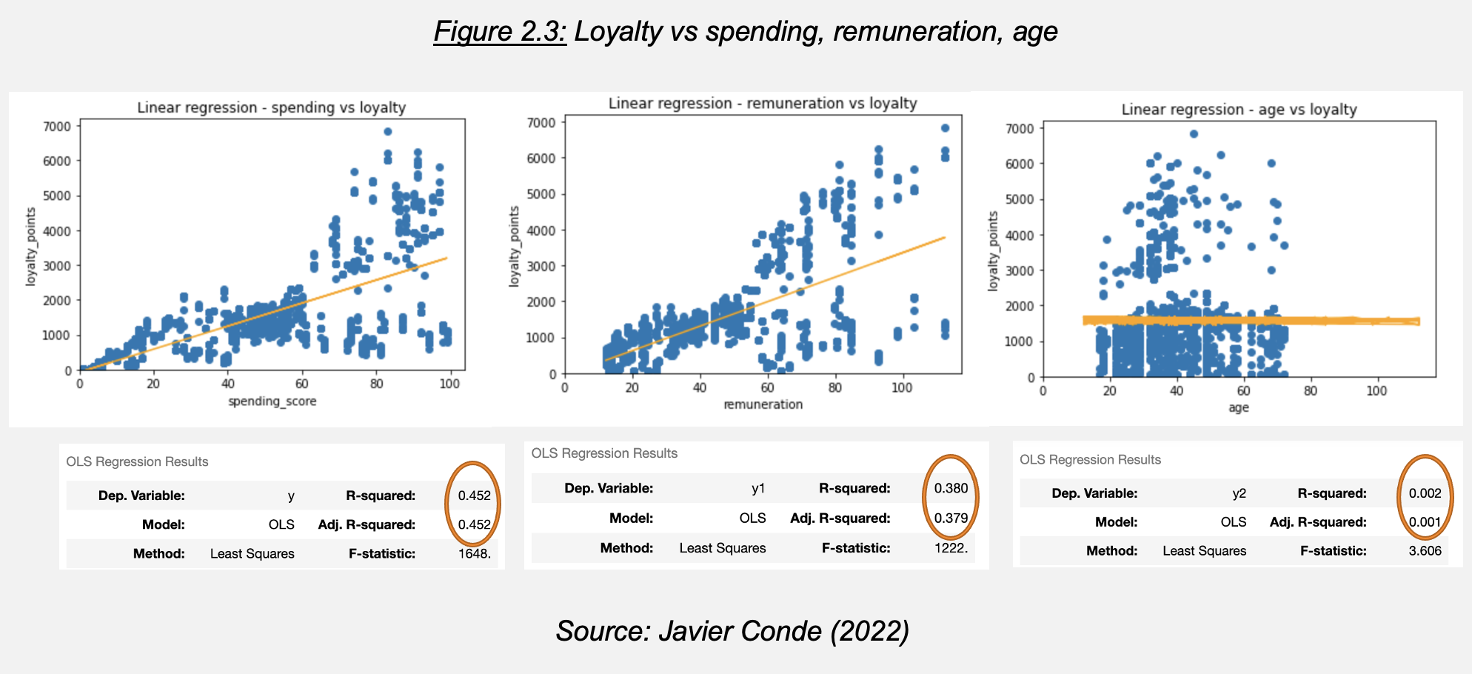

There is a slight correlation between variables ‘spending’ and ‘remuneration’ with ‘loyalty’ (Adjusted R2 measure 0.45 (spending) and 0.37 (remuneration)) but almost no correlation with ‘age’ (Adjusted R2 0.001). As marketing department requests to study ‘spending’/’remuneration’ further, let’s now identify groups within the customer base that can be used to target specific market segments regarding both variables through k-means clustering.

**2.1.2. Customer Clustering**

Let’s study further ‘spending’/’remuneration’ relationship with Seaborn using a regression scatterplot and a pairplot (Figures 2.4 and 2.5).

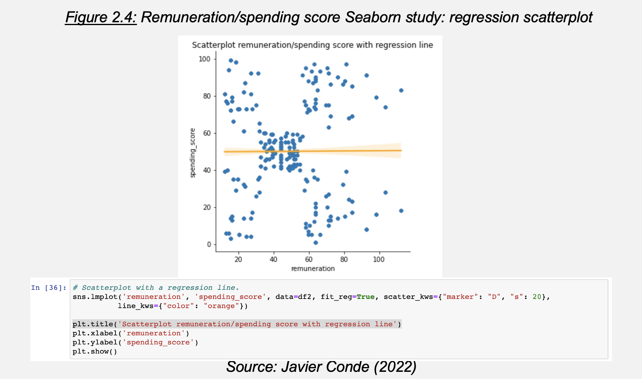

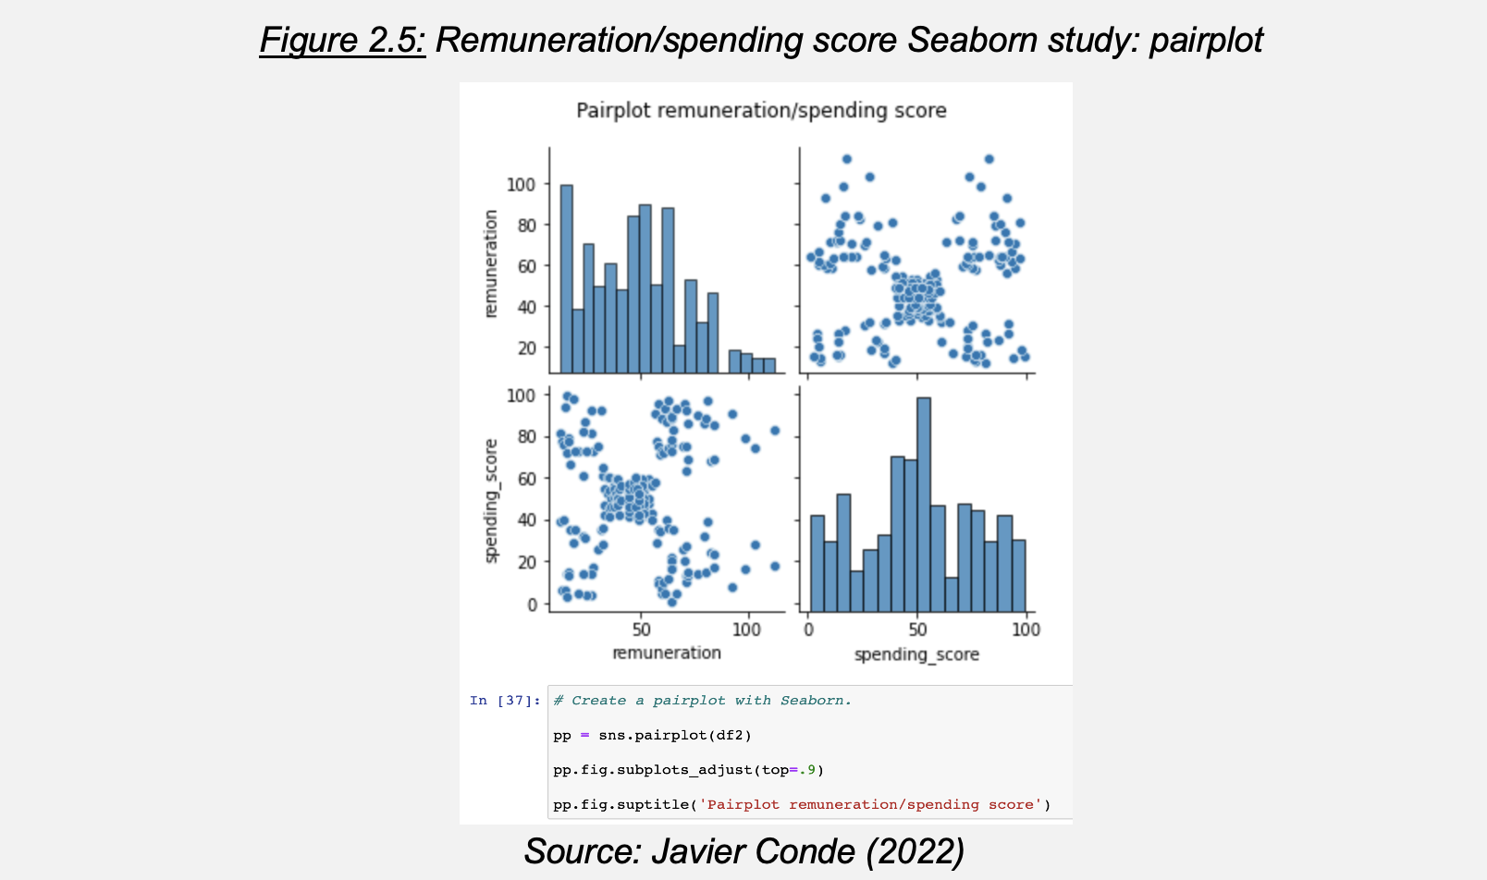

The pairplot uncovers four/five possible customer clusters that could be targeted. Through the Elbow and Silhouette methods it is determined that optimal cluster number (‘k’) is 5 (Figure 2.6). Let’s evaluate suitability of k=5 and other alternatives (i.e., 6/7) through k-means modelling.

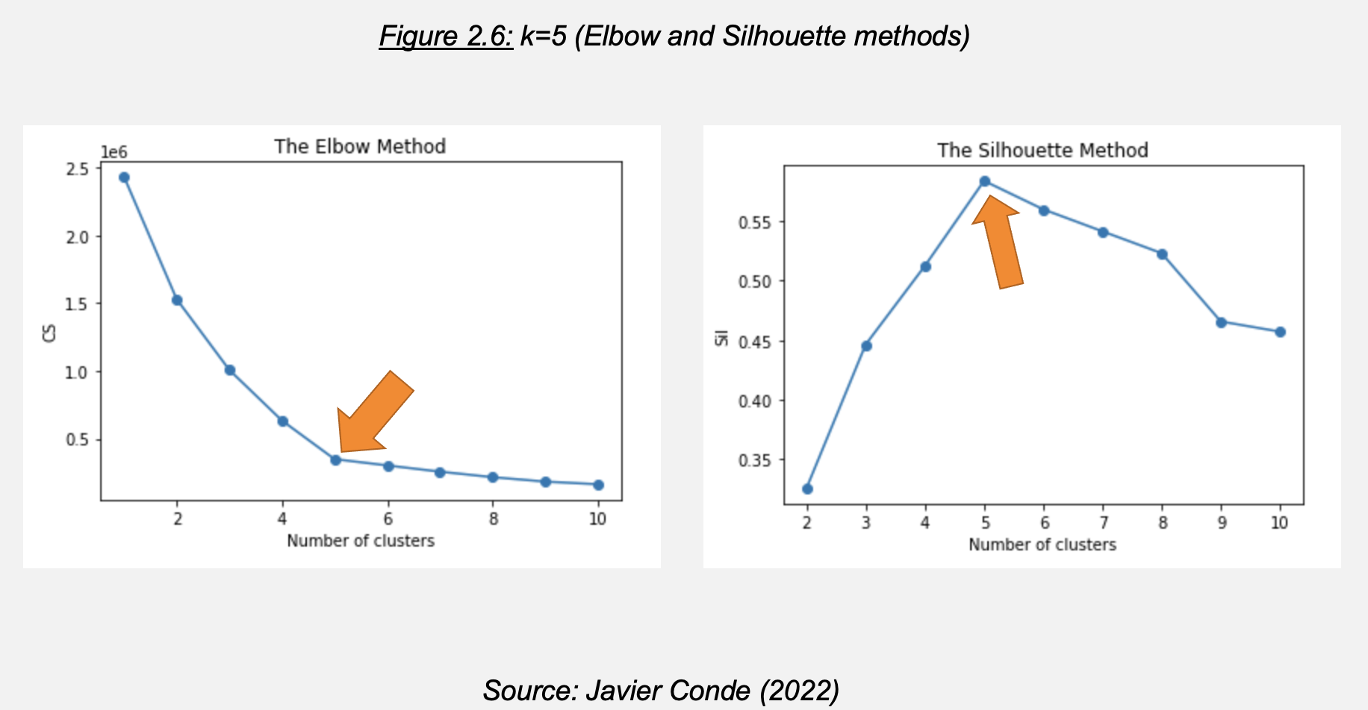

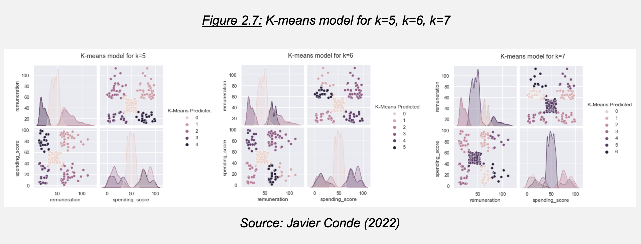

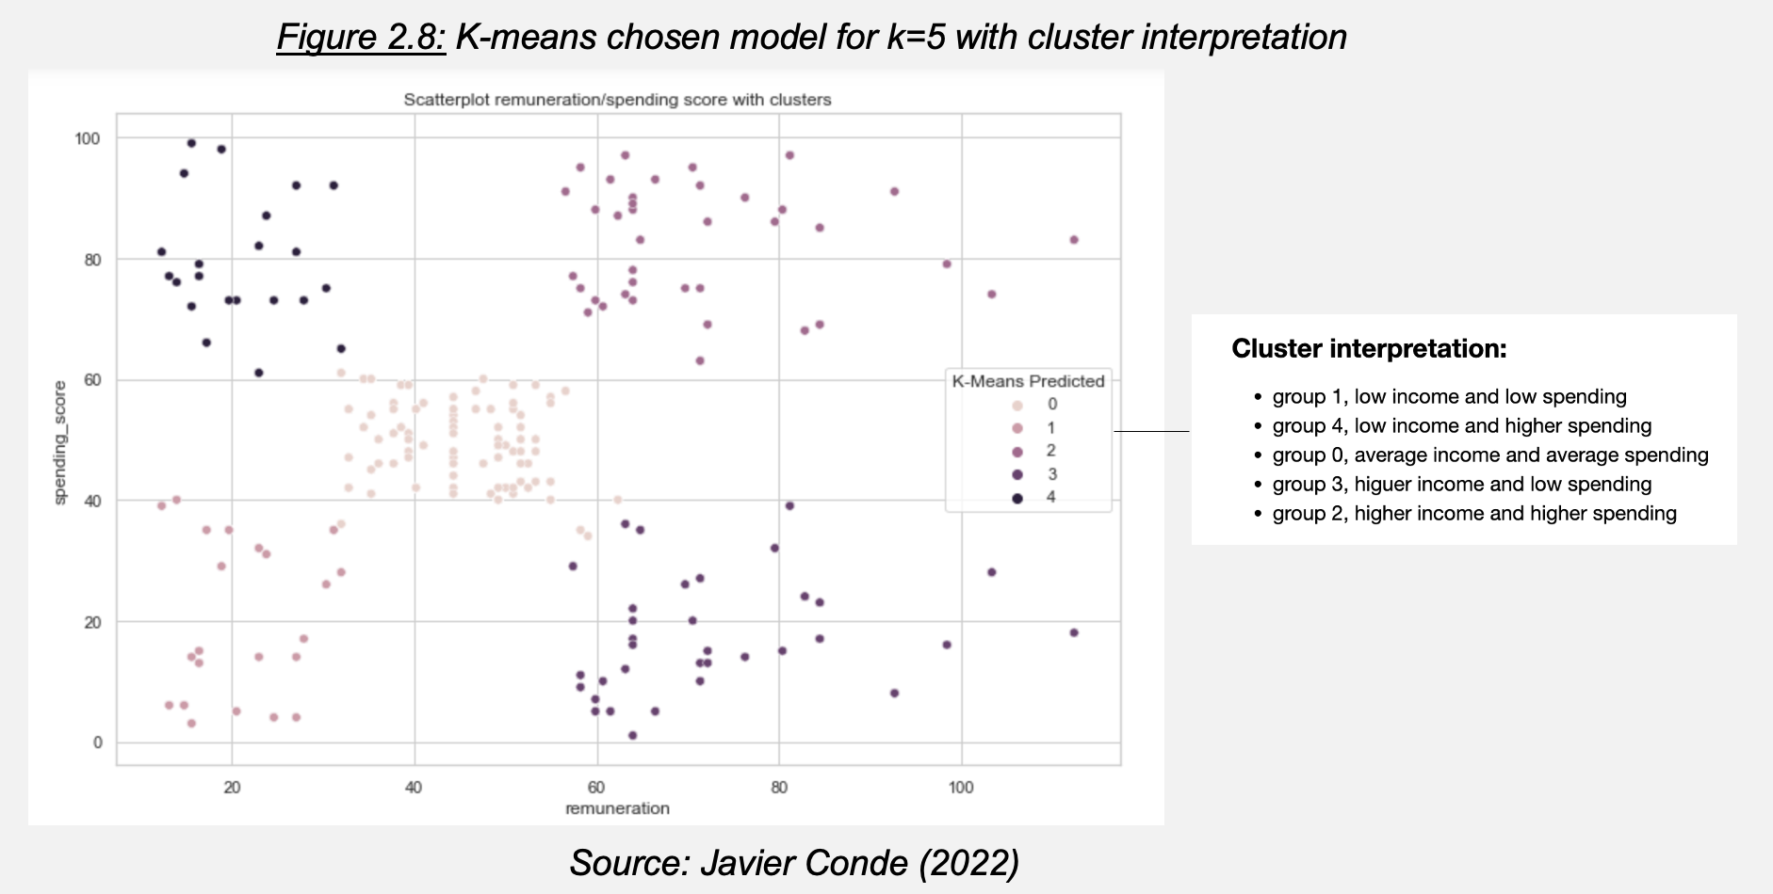

Figure 2.7 and Figure 2.8 show that k=5 returns the best customer grouping as it provides a good separation between groups. Therefore, it would be recommended to Turtle Games’ marketing department to consider these 5 possible customer clusters in relation to their remuneration and spending score (as also evidenced by the result of the Elbow/Silhouette methods) among other variables.

As the marketing department has requested more information about reviews to approach future campaigns, let’s study the reviews file provided and sentiment behind them through Natural Language Processing (NPL) analysis.

**2.1.3. NPL using Python on customer reviews**

The focus of the analysis will be ‘review’ and ‘summary’ columns from the ‘turtle_reviews file’. A new data frame is created only with them, removing lower cases, punctuation, and cleaning duplicates prior to tokenization (Figure 2.9). Then a word cloud with stop words removed is created for visibility (Figure 2.10). Analysis on count of 15 most frequent words and polarity/sentiment in both columns follows (Figure 2.11).

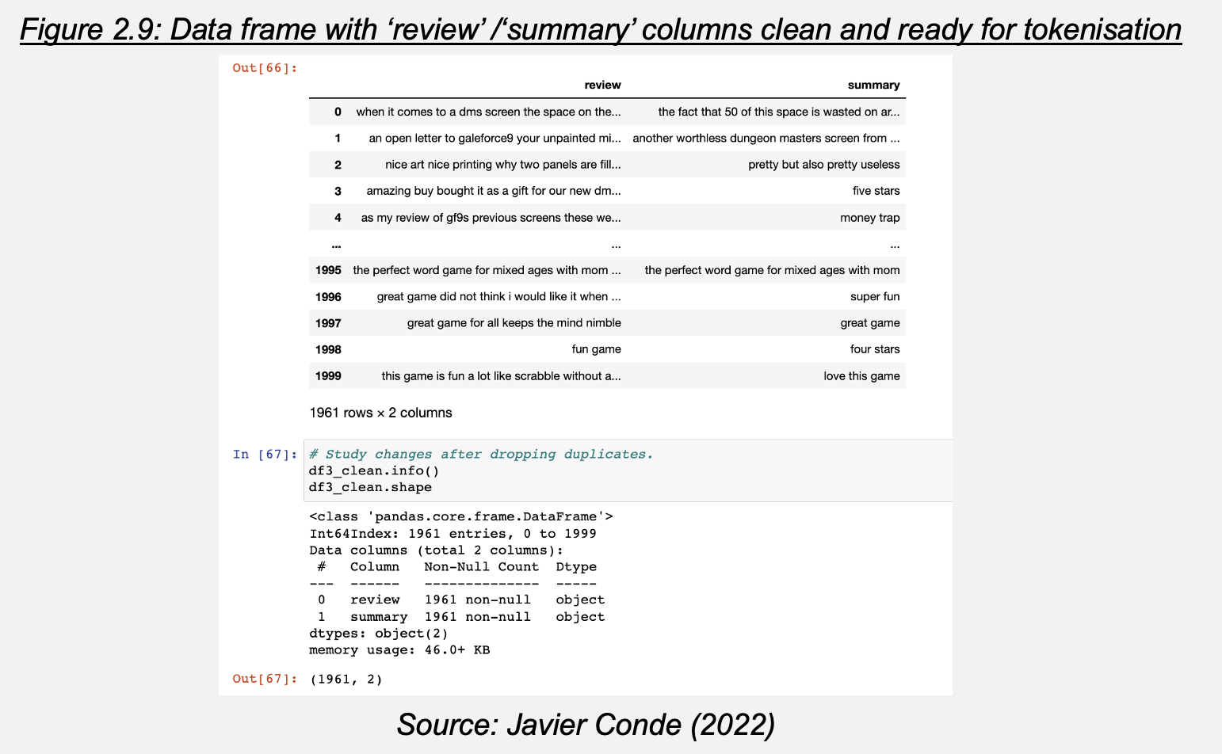

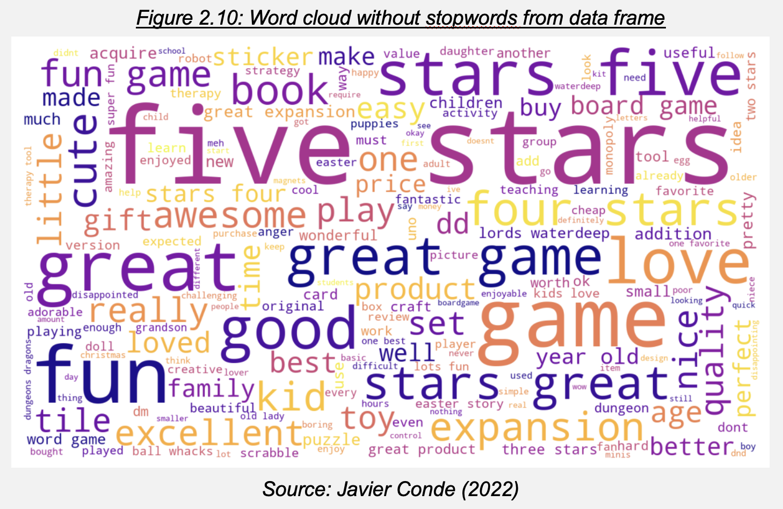

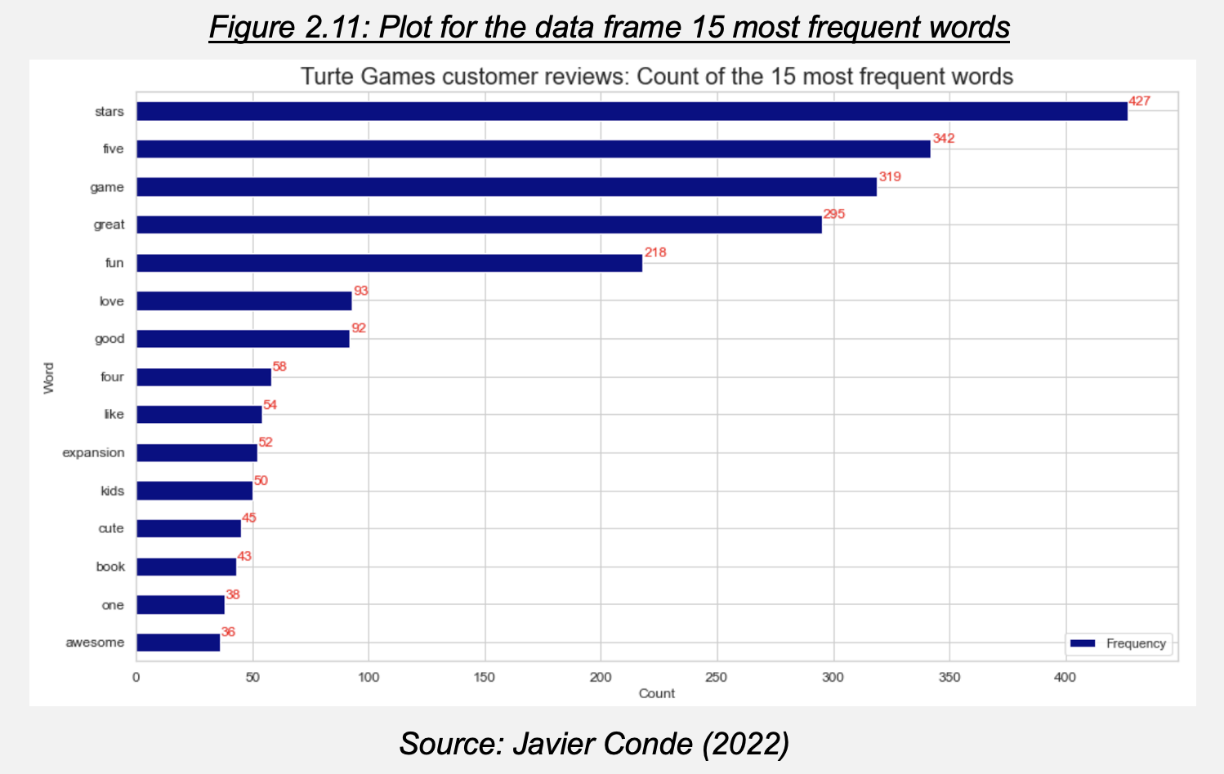

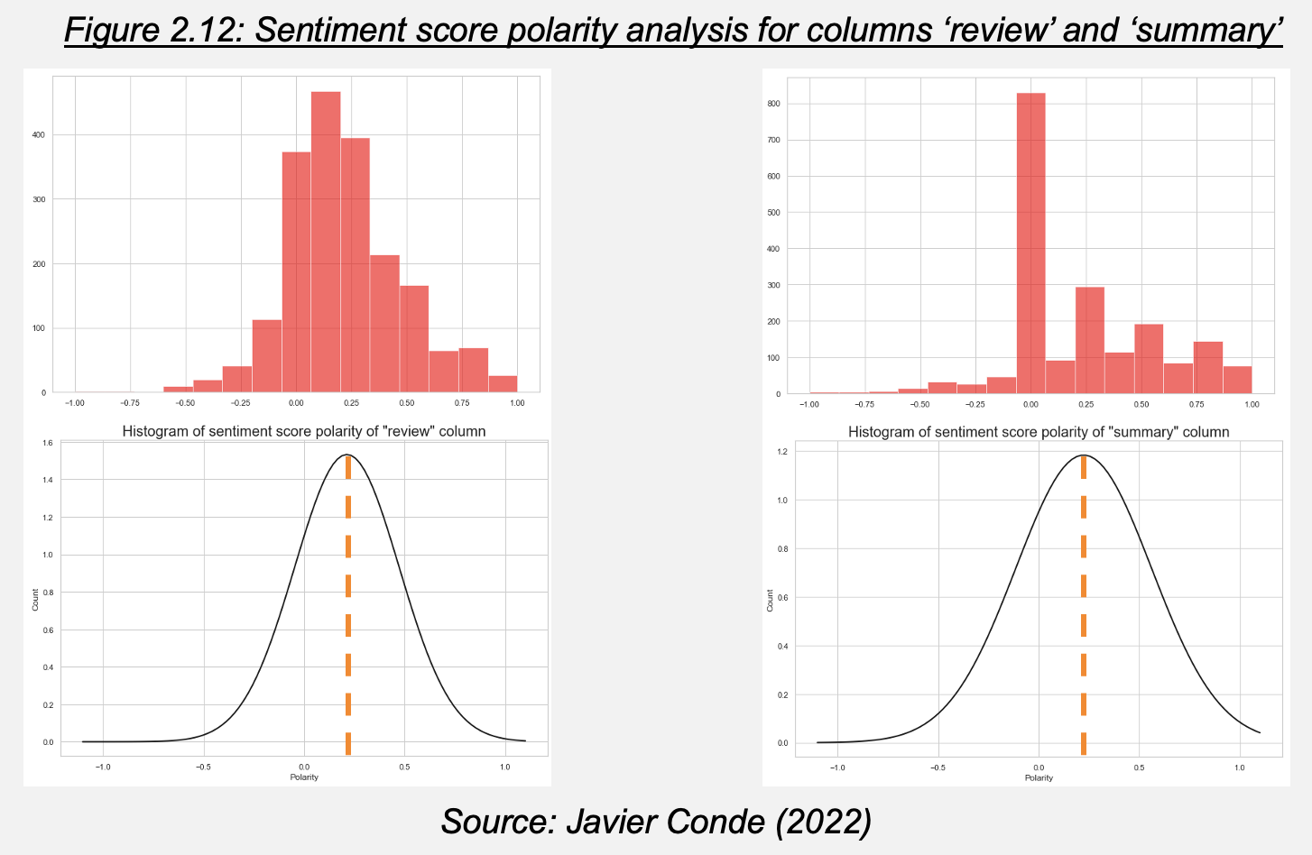

The first most frequent words being “stars” and “five” and sentiment/polarity score Mean in both columns between +0.2 to +0.25 signal to a slightly positive sentiment towards Turtle Games products. Further analysis on customer reviews to better understand points of improvement and ‘best of’ comments is recommended.

Let’s now analyze sales performance from the company products, this time using R as it is the preferred tool for the sales department.

**2.2 Sales data analysis**

**2.2.1. Exploratory Data Analysis (EDA) on sales with R**

After importing the relevant packages and exploring structure and summary of the provided data (‘turtle_sales’) (Figure 2.13), a subset is created (‘turtle_sales2’) containing products ID, creation platforms, and sales figures (European Union (EU), North America (NA) and global) (Figure 2.14).

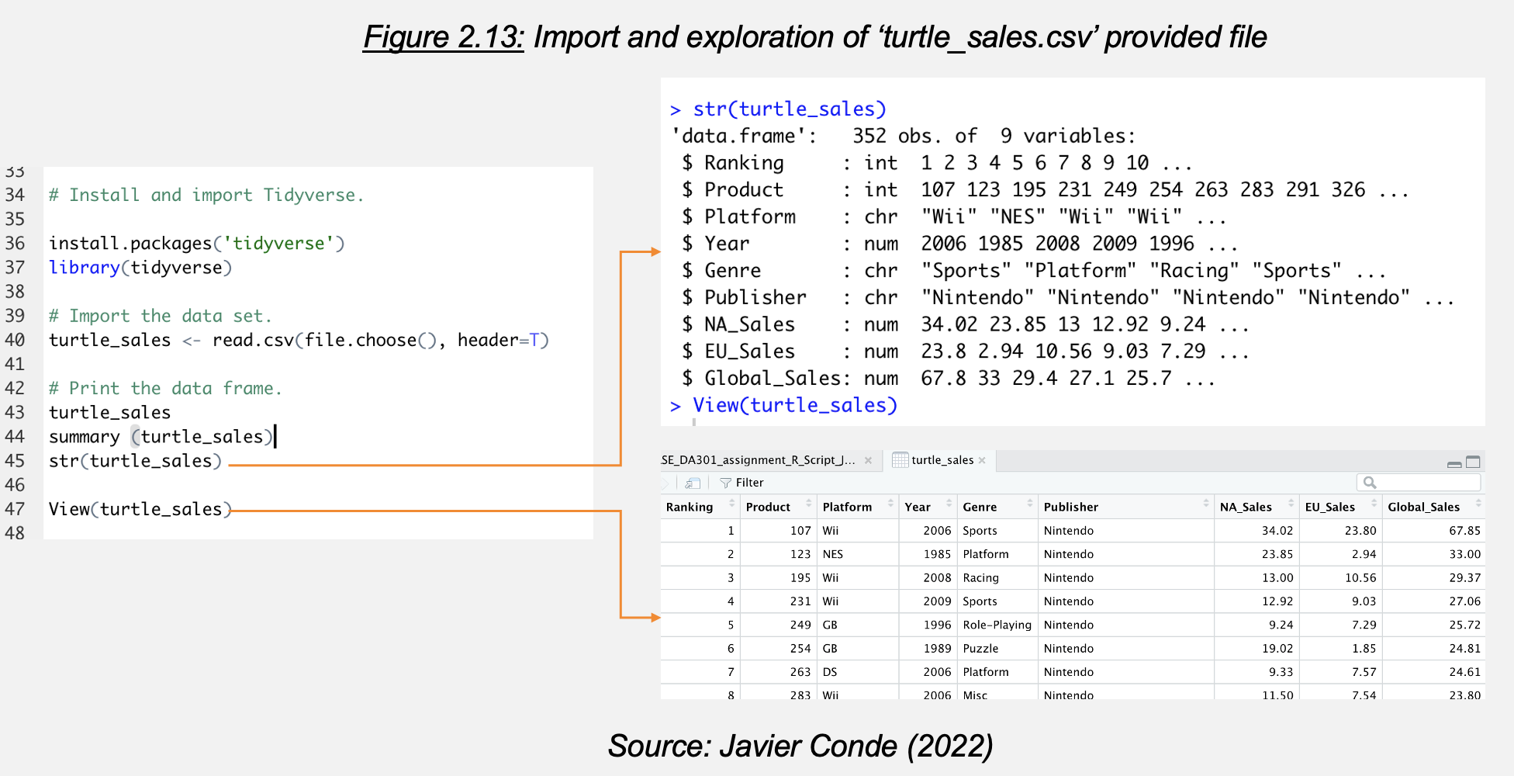

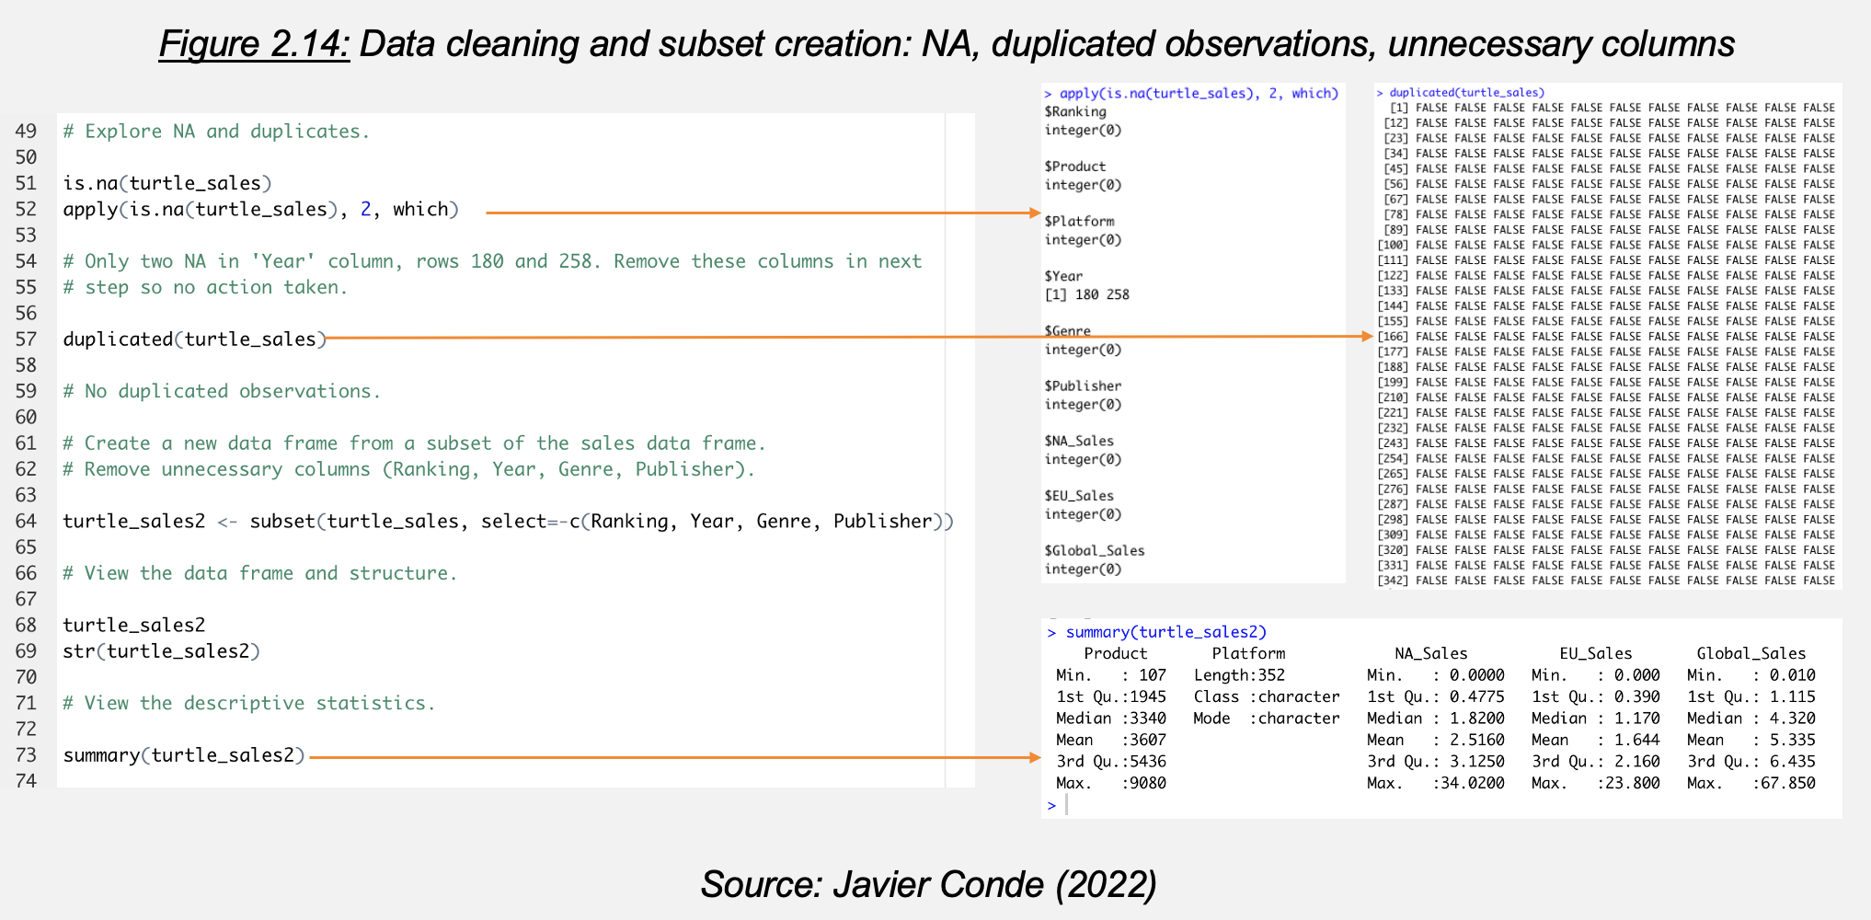

This clean data set is initially studied through simple exploratory scatterplots (Figure 2.15), histograms (Figure 2.16) and boxplots (Figure 2.17).

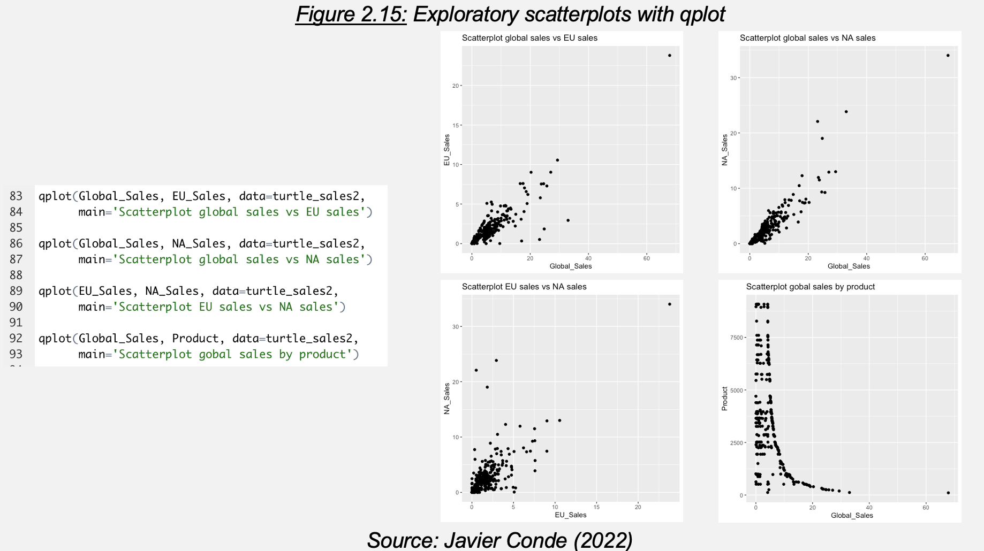

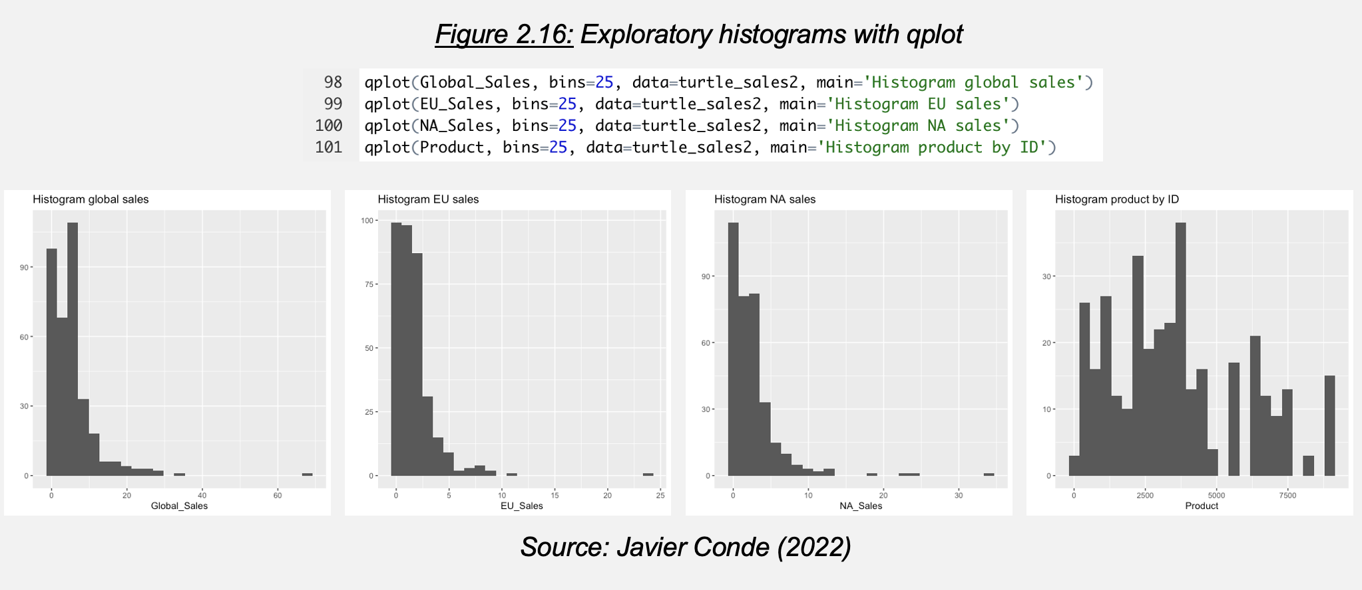

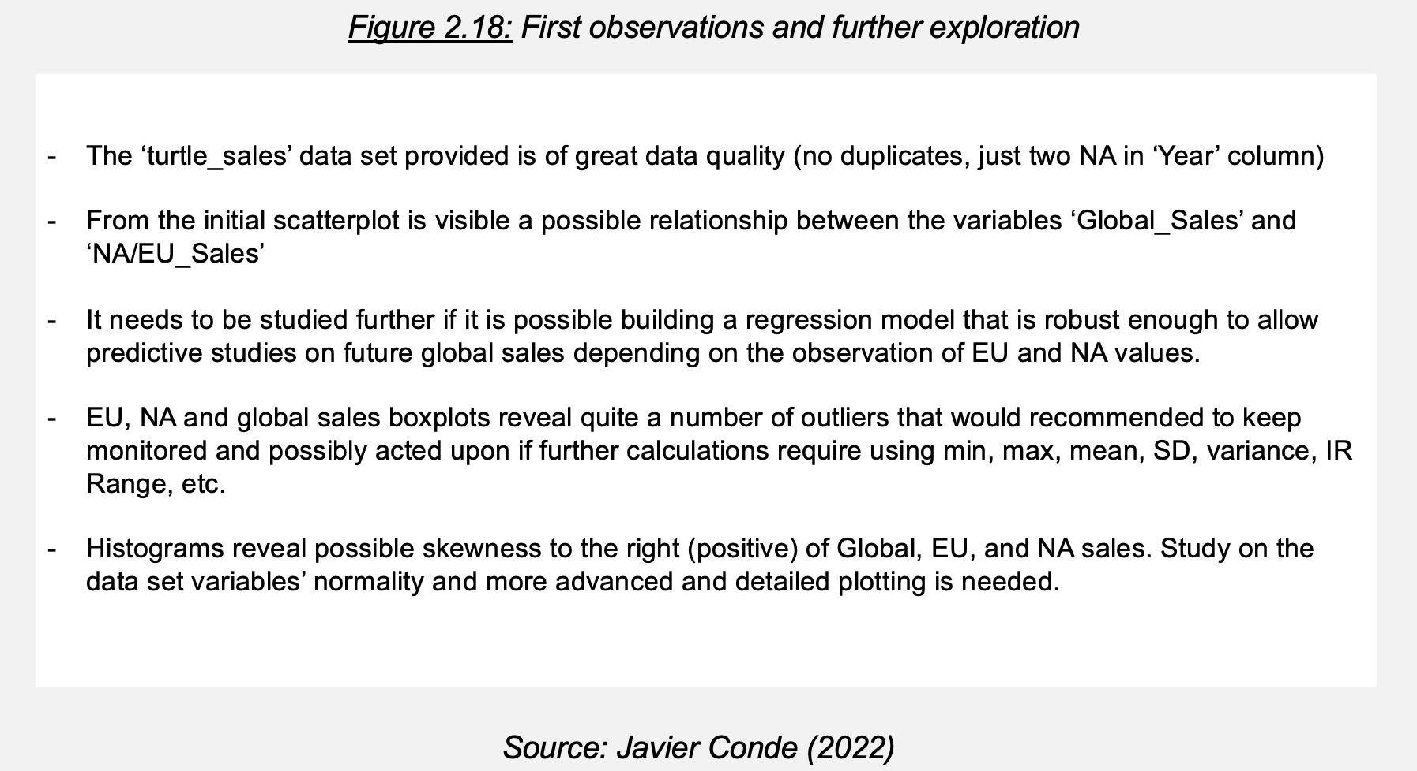

This first approach reveals more study needed on normality with a more detailed plotting package (Figure 2.18). Let’s explore these topics.

**2.2.2. Data set normality and advanced plotting**

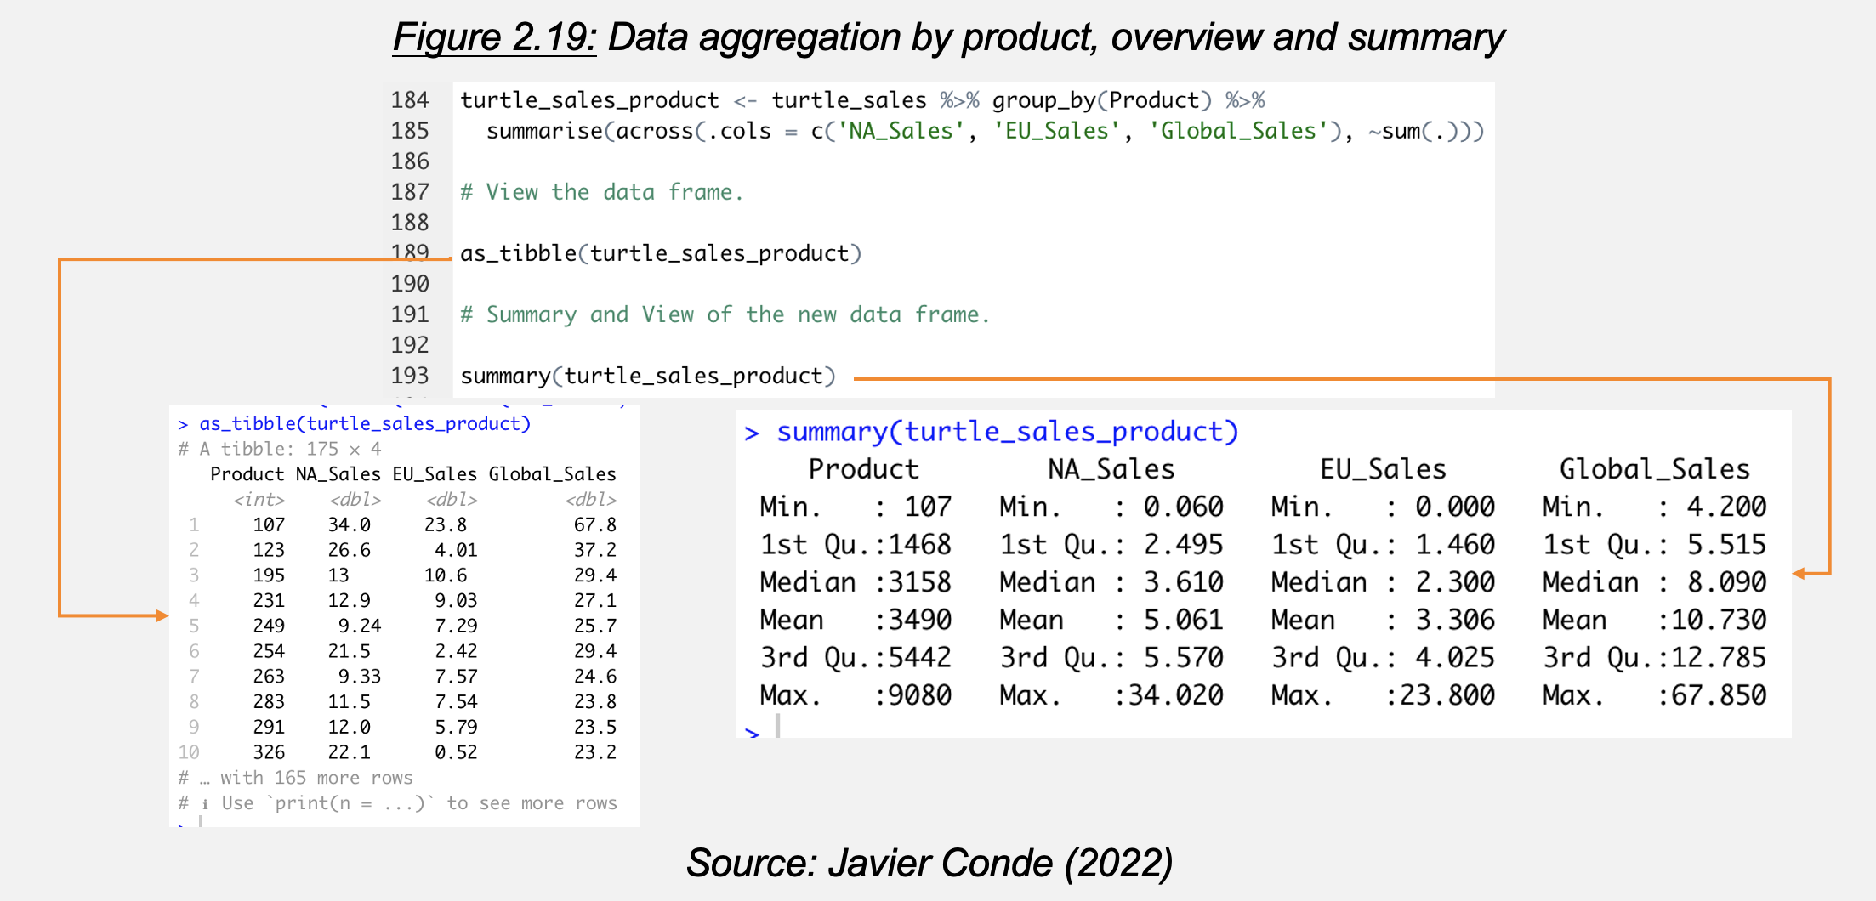

To facilitate the analysis let’s aggregate the sales data based on product and check results with as_tibble() function. Result data frame ‘turtle_sales_product’ (Figure 2.19) is used for analysis on QQ plotting, Shapiro-Wilk testing, skewness and kurtosis, variables correlation, and advanced plotting (Figures 2.20 to 2.25).

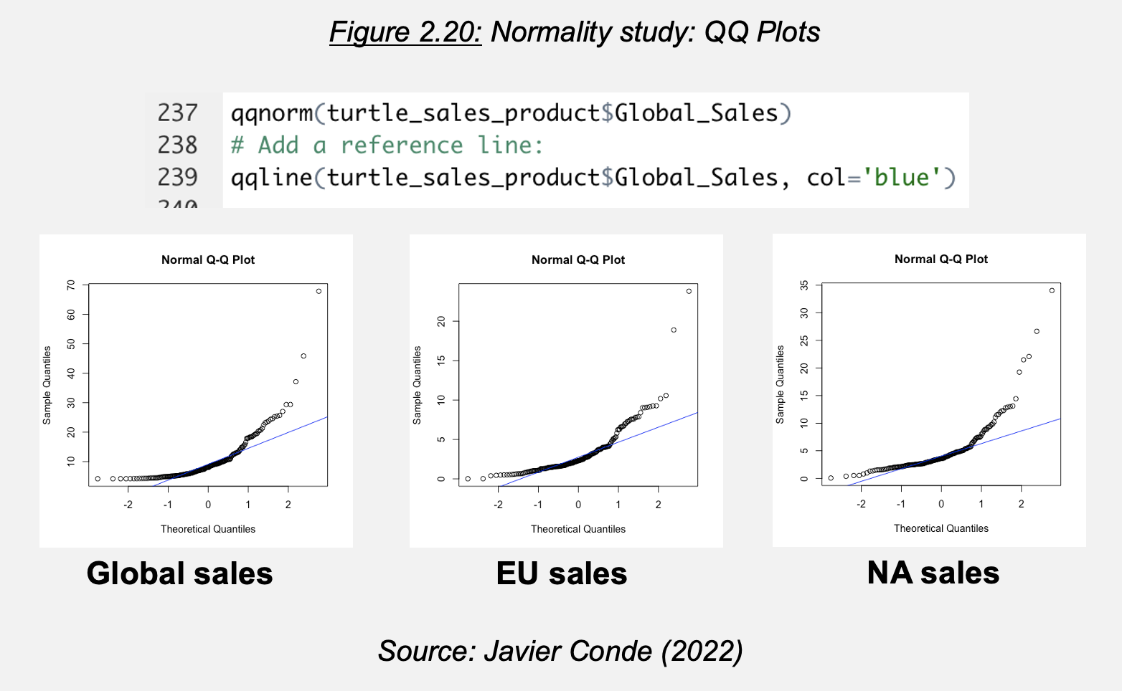

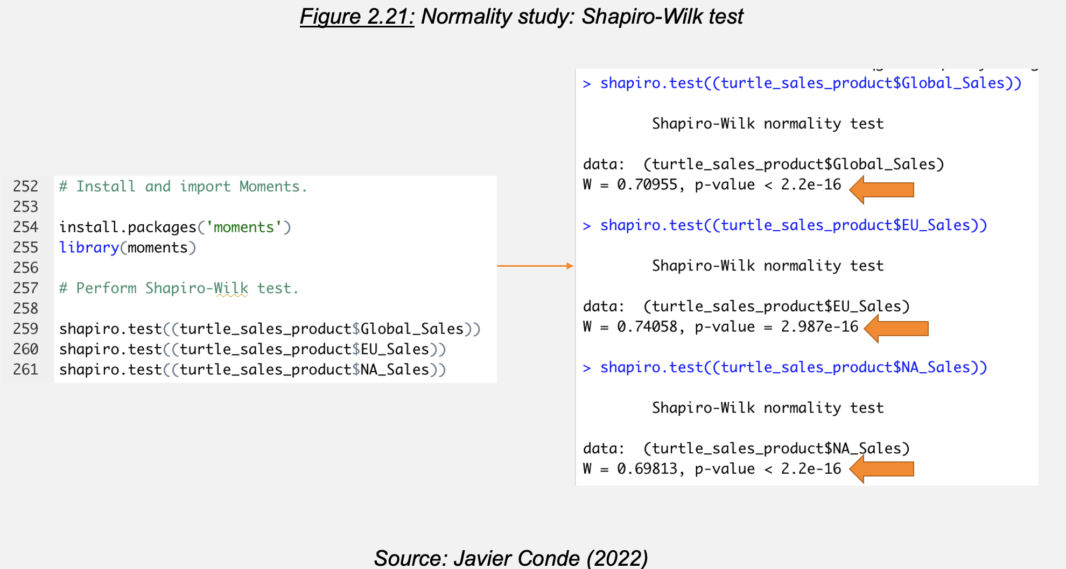

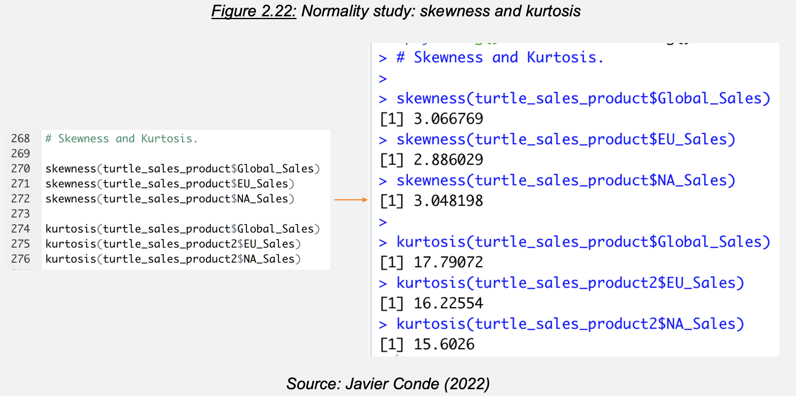

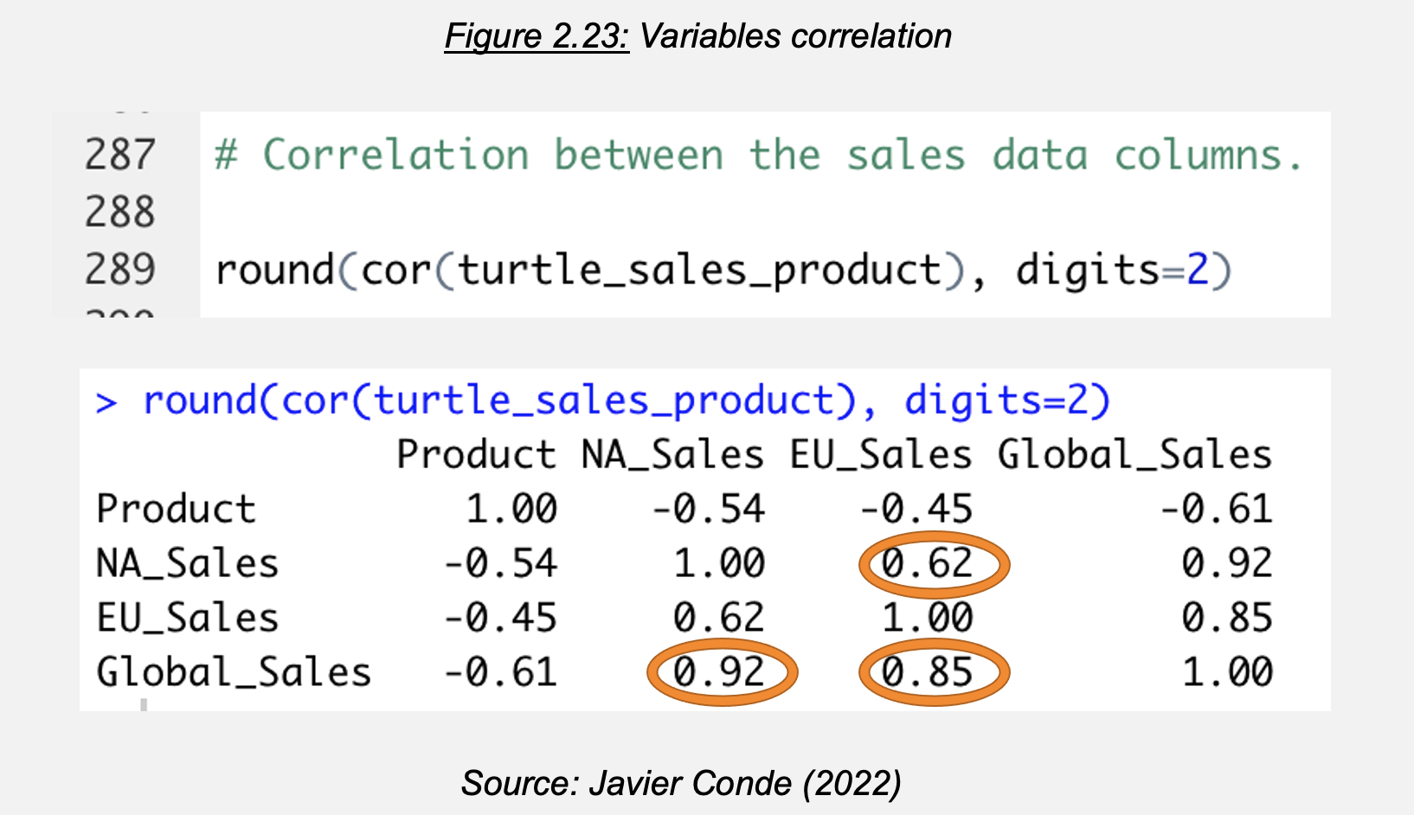

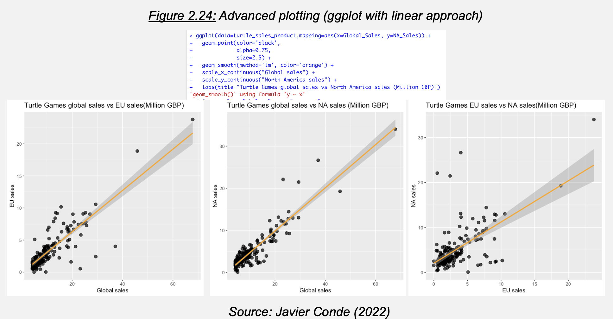

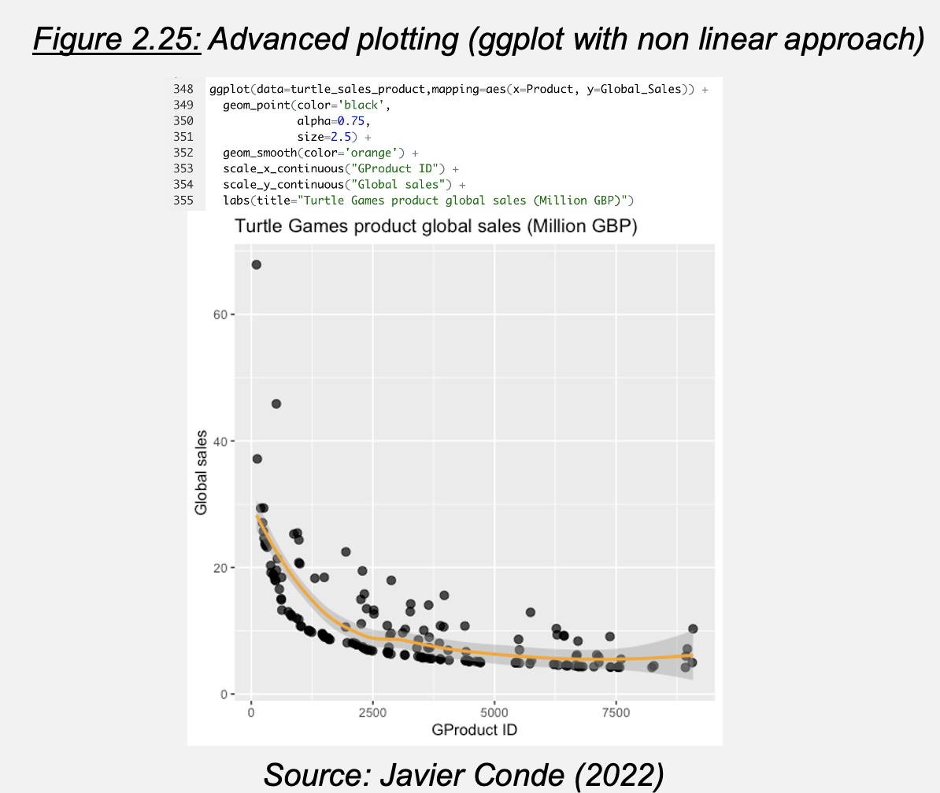

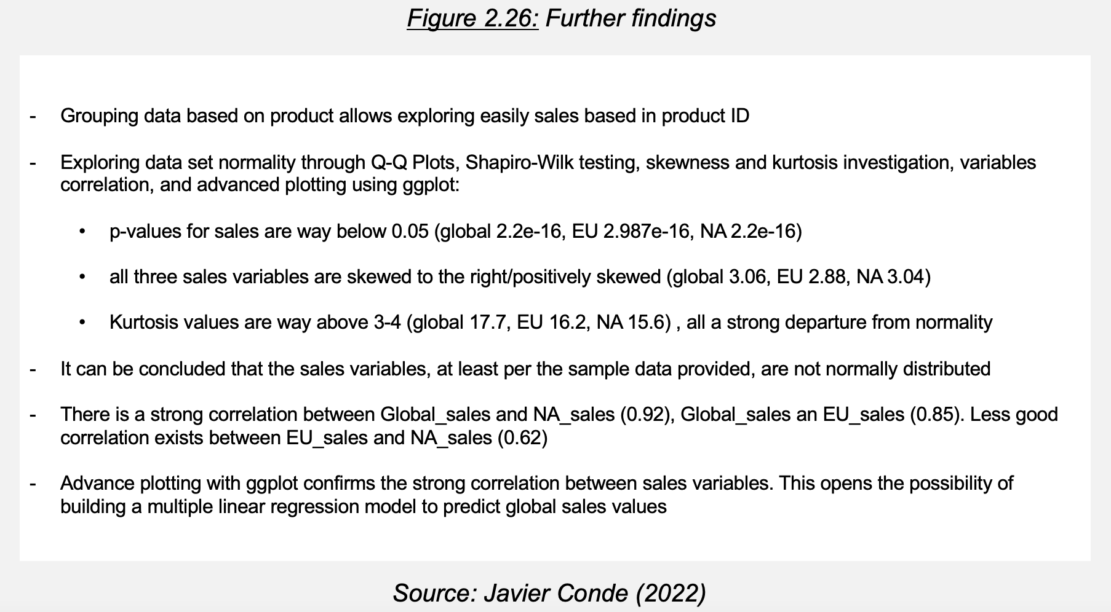

The findings (Figure 2.26) lead the project to conclusion evaluating how robust a potential Multiple Linear Regression model (MLR) predicting global sales based in NA and EU sales could be.

**2.2.3. MLR model and value prediction**

Once correlation strength is analyzed between all three variables through simple cross modelling (Figures 2.27, 2.28), we use EU and NA sales to create a MLR model (modelA, Figure 2.31) and an alternative including variable ‘product’ (modelB, Figure 2.32) for further study. We complete our study testing modelA’s accuracy on 5 aleatory observed values (Figures 2.33 to 2.35).

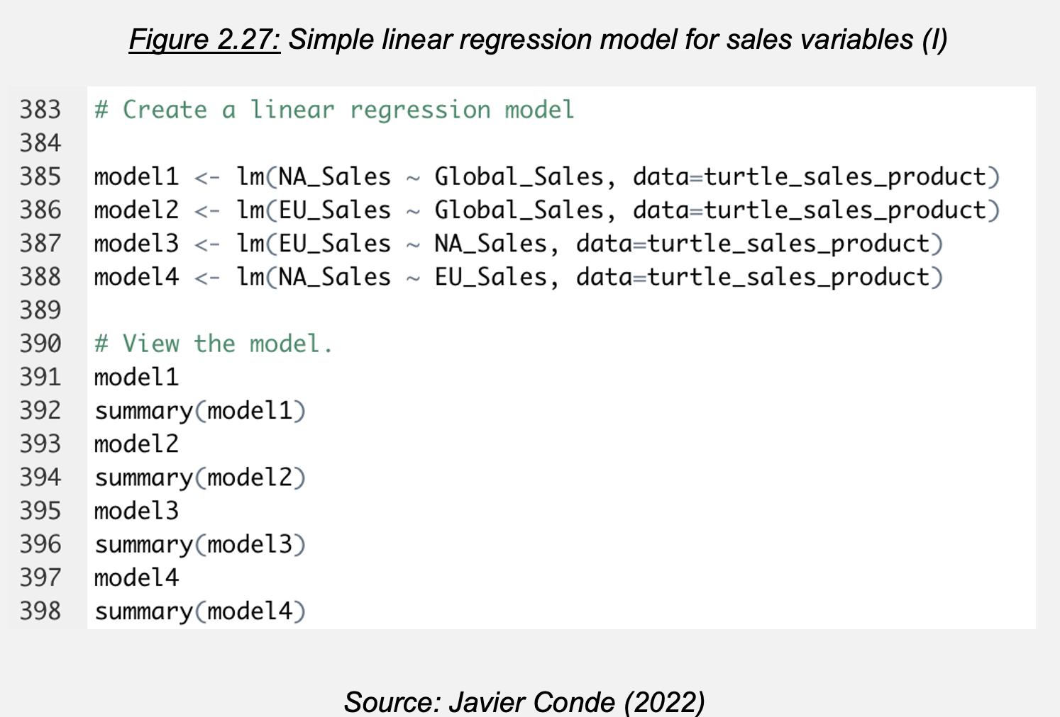

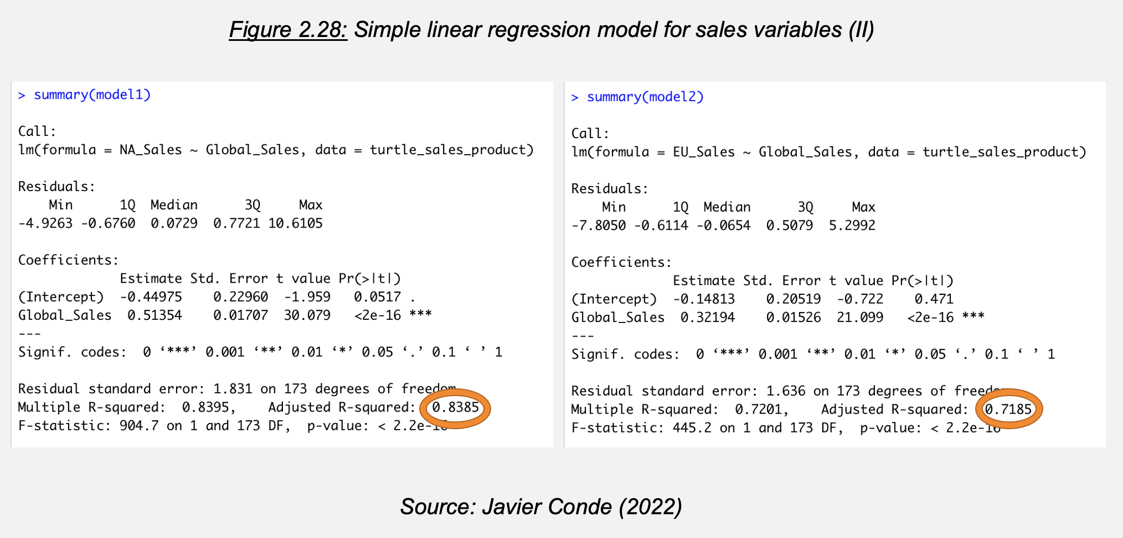

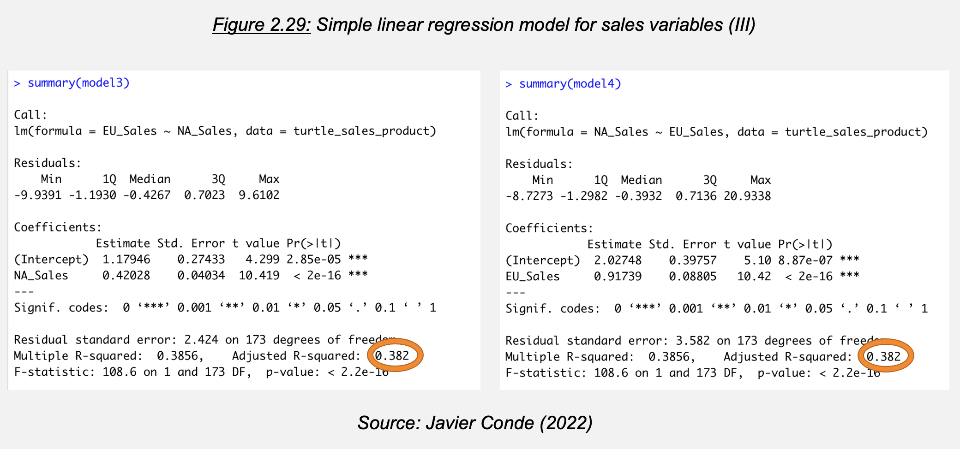

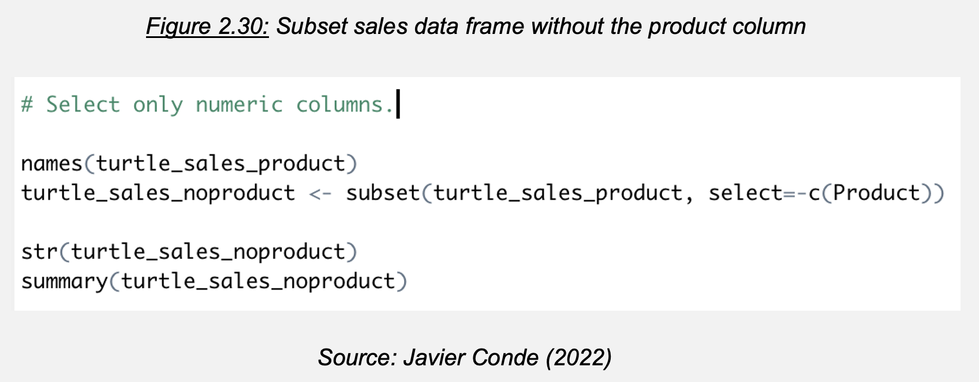

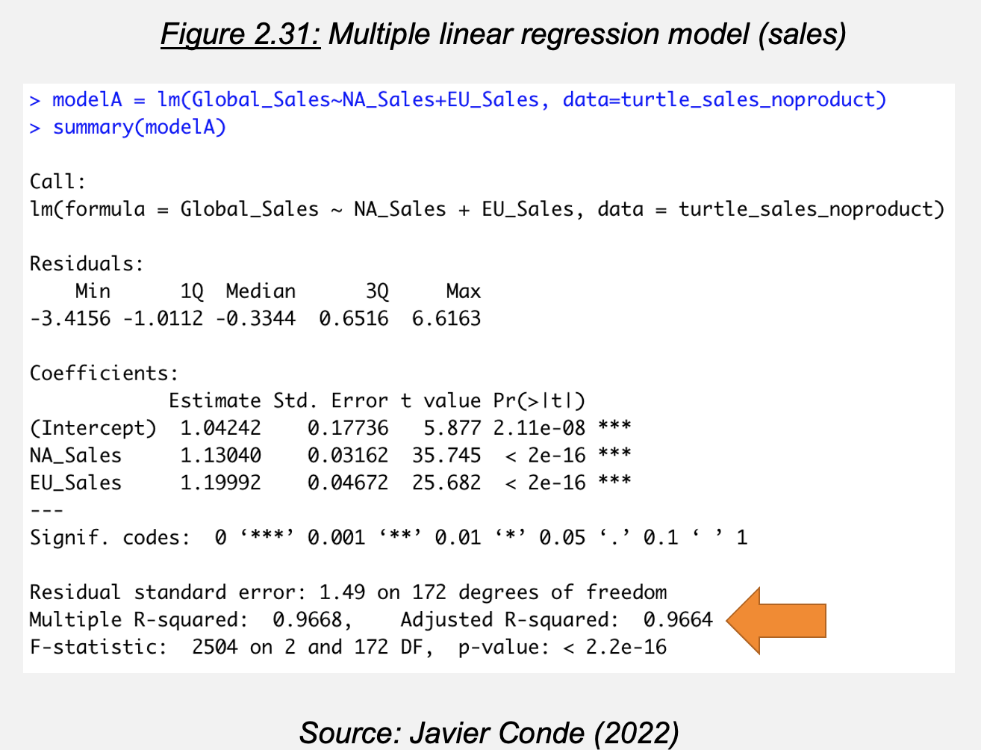

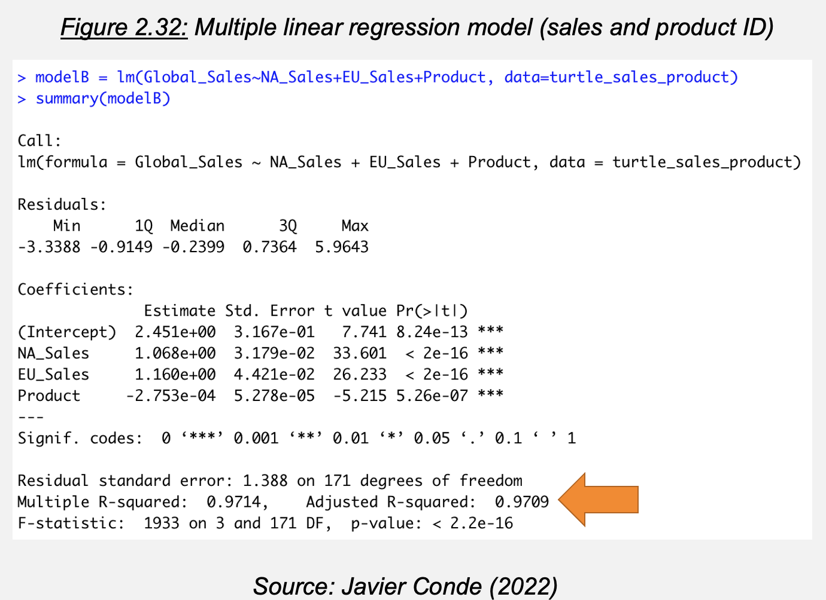

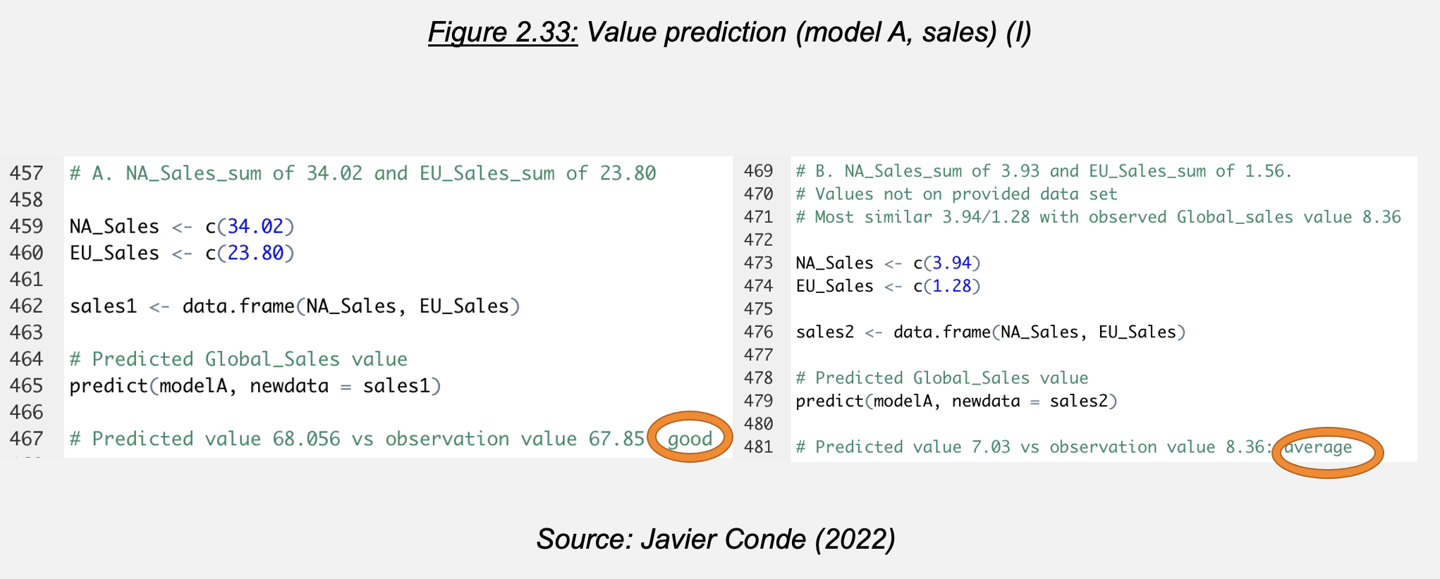

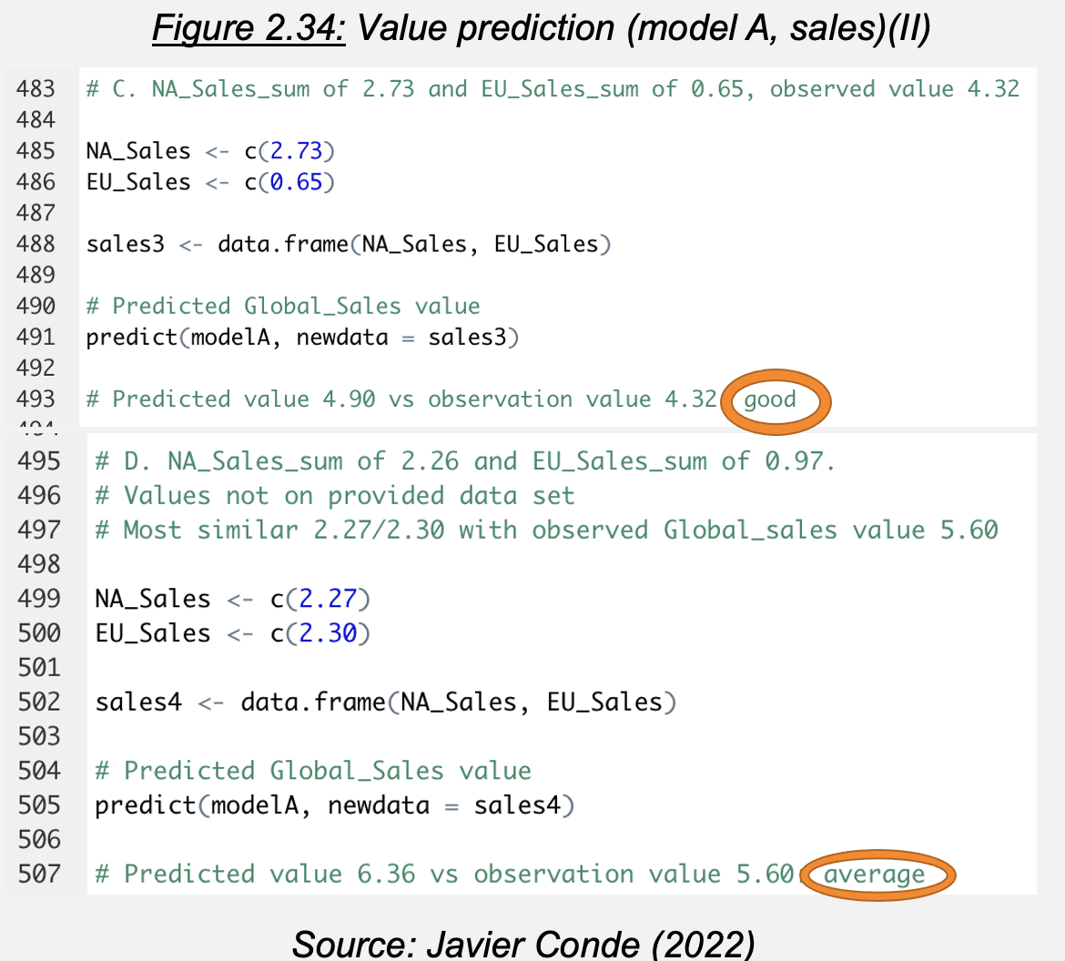

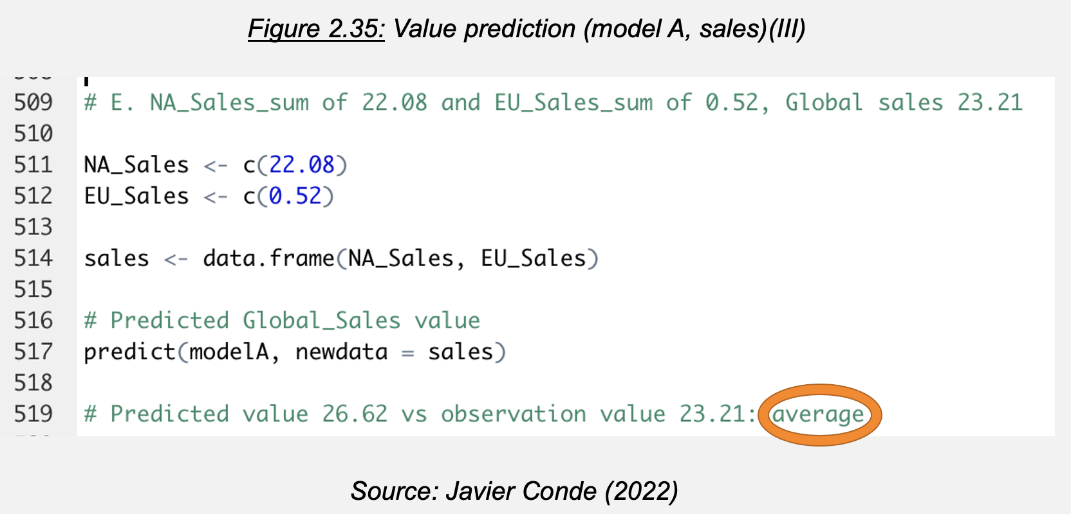

With the analysis now fully completed, it is time to review insights and recommendations to the business with all the answers from the key initial questions.

Chapter 3

**Insights and recommendations**

Insights: Figures 3.1, 3.2.

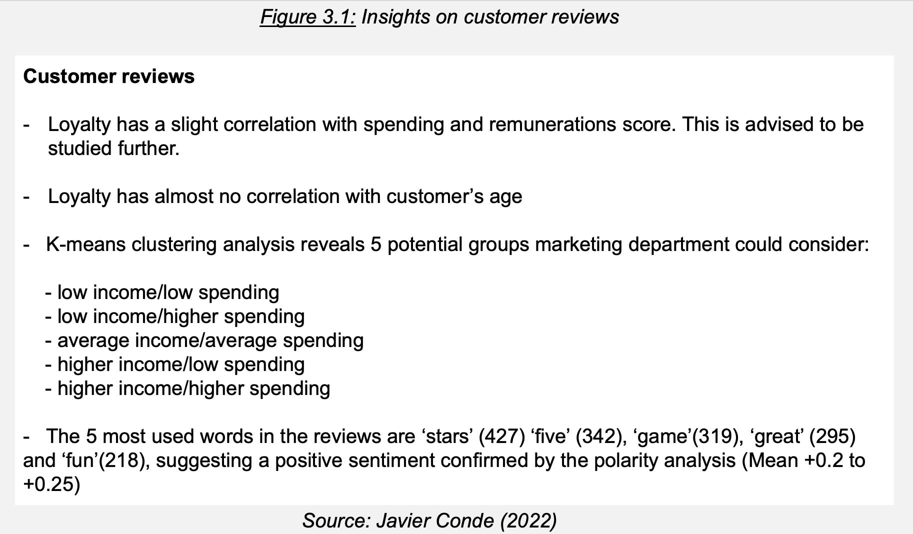

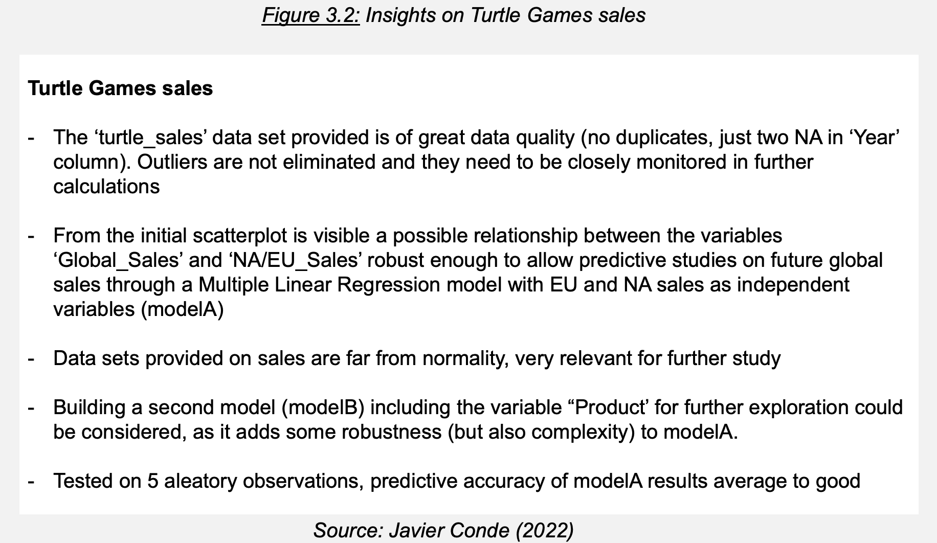

Recommendations: Figures 3.3 to 3.5.

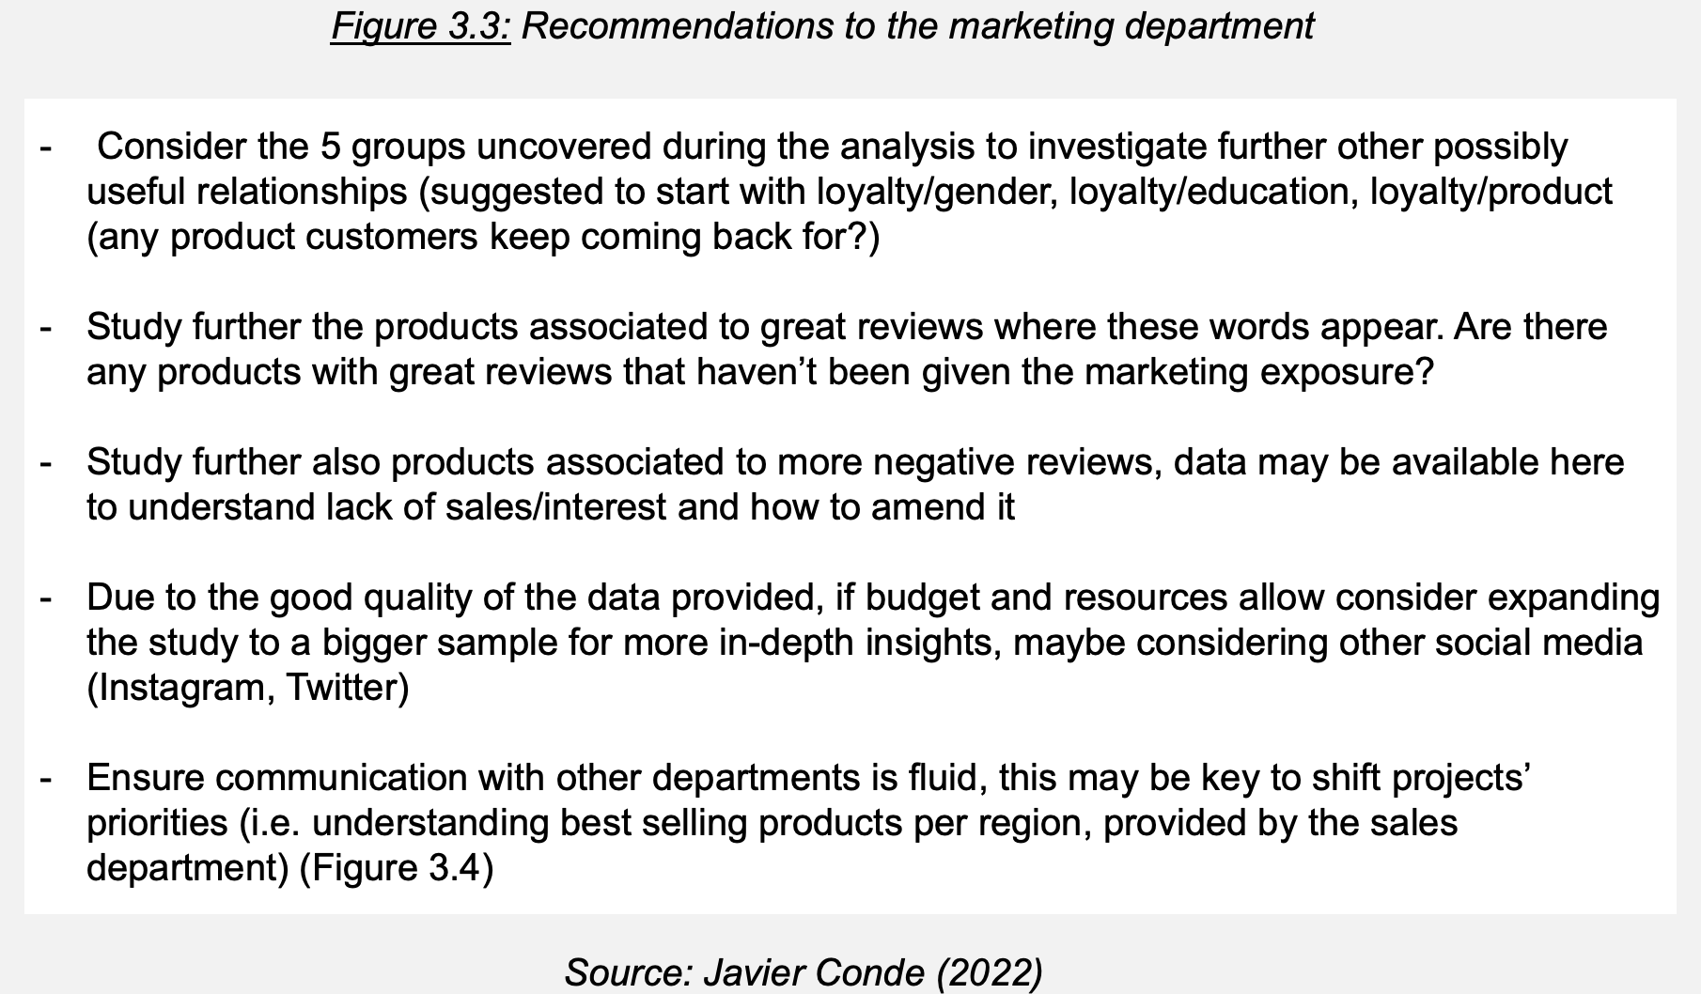

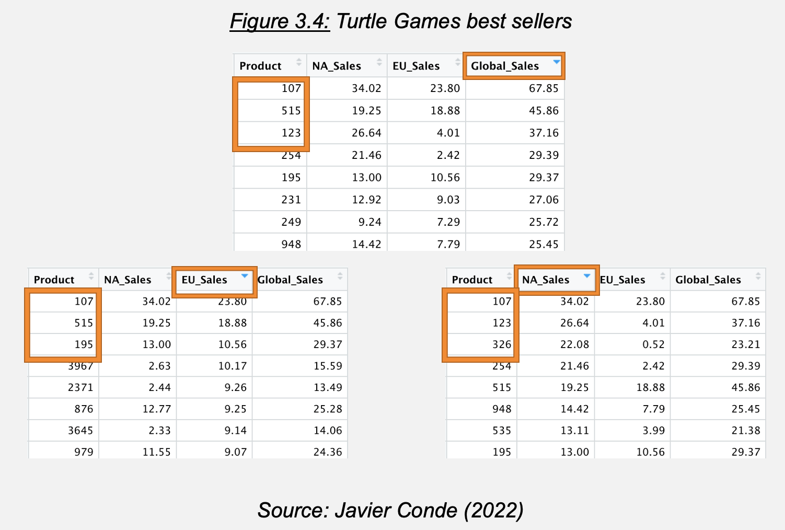

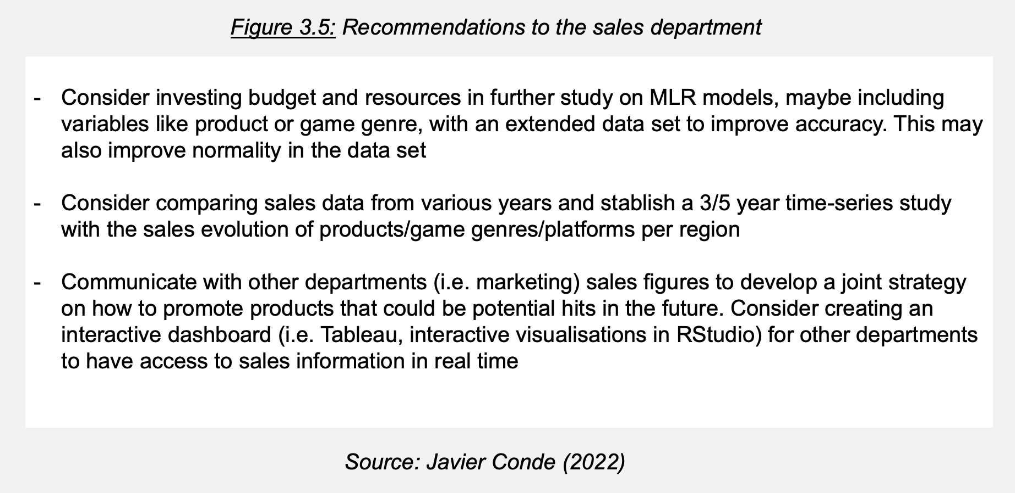

**List of Figures**

* Figure 1.1: Background, project goal and questions to answer (LSE, 2022)
* Figure 1.2: Project Github repository (I) (Javier Conde, 2022)
* Figure 1.3: Project Github repository (II) (Javier Conde, 2022)
* Figure 2.1: Data clean and re-import process (I) (Javier Conde, 2022)
* Figure 2.2: Data clean and re-import process (II) (Javier Conde, 2022)
* Figure 2.3: Loyalty vs spending, remuneration, age (Javier Conde, 2022)
* Figure 2.4: Remuneration/spending score Seaborn study: regression scatterplot (Javier Conde, 2022)
* Figure 2.5: Remuneration/spending score Seaborn study: pairplot (Javier Conde, 2022)
* Figure 2.6: Figure 2.6: k=5 (Elbow and Silhouette methods) (Javier Conde, 2022)
* Figure 2.7: K-means model for k=5, k=6, k=7 (Javier Conde, 2022)
* Figure 2.8: K-means chosen model for k=5 with clusters interpretation (Javier Conde, 2022)
* Figure 2.9: Data frame with ‘review’ /‘summary’ columns clean and ready for tokenisation (Javier Conde, 2022)
* Figure 2.10: Word cloud without stopwords from data frame (Javier Conde, 2022)
* Figure 2.11: Plot for the data frame 15 most frequent words (Javier Conde, 2022)
* Figure 2.12: Sentiment score polarity analysis for columns ‘review’ and ‘summary’ (Javier Conde, 2022)
* Figure 2.13: Import and exploration of ‘turtle_sales.csv’ provided file (Javier Conde, 2022)
* Figure 2.14: Data cleaning and subset creation: NA, duplicated observations, unnecessary columns (Javier Conde, 2022)
* Figure 2.15: Exploratory scatterplots with qplot (Javier Conde, 2022)
* Figure 2.16: Exploratory histograms with qplot (Javier Conde, 2022)
* Figure 2.17: Exploratory boxplots with qplot (Javier Conde, 2022)
* Figure 2.18: First observations and further exploration (Javier Conde, 2022)
* Figure 2.19: Data aggregation by product, overview and summary (Javier Conde, 2022)
* Figure 2.20: Normality study: QQ Plots (Javier Conde, 2022)
* Figure 2.21: Normality study: Shapiro-Wilk test (Javier Conde, 2022)
* Figure 2.22: Normality study: skewness and kurtosis (Javier Conde, 2022)
* Figure 2.23: Variables correlation (Javier Conde, 2022)
* Figure 2.24: Advanced plotting (ggplot with linear approach) (Javier Conde, 2022)
* Figure 2.25: Advanced plotting (ggplot with non-linear approach) (Javier Conde, 2022)
* Figure 2.26: Further findings (Javier Conde, 2022)
* Figure 2.27: Simple linear regression model for sales variables (I) (Javier Conde, 2022)
* Figure 2.28: Simple linear regression model for sales variables (II) (Javier Conde, 2022)
* Figure 2.29: Simple linear regression model for sales variables (II) (Javier Conde, 2022)
* Figure 2.30: Subset sales data frame without the product column (Javier Conde, 2022)
* Figure 2.31: Multiple linear regression model (sales) (Javier Conde, 2022)
* Figure 2.32: Multiple linear regression model (sales and product ID) (Javier Conde, 2022)
* Figure 2.33: Value prediction (model A, sales) (I) (Javier Conde, 2022)
* Figure 2.34: Value prediction (model A, sales) (II) (Javier Conde, 2022)
* Figure 2.35: Value prediction (model A, sales) (III) (Javier Conde, 2022)
* Figure 3.1: Insights on customer reviews (Javier Conde, 2022)
* Figure 3.2: Insights on Turtle Games sales (Javier Conde, 2022)
* Figure 3.3: Recommendations to the marketing department (Javier Conde, 2022)
* Figure 3.4: Turtle Games best sellers (Javier Conde, 2022)
* Figure 3.5: Recommendations to the sales department (Javier Conde, 2022)